**Calculation the biocarrier**

Weighting biocarriers

**RFK-25L-PE (BLACK)**

|  |  |  |  |  |  |
| --- | --- | --- | --- | --- | --- |
| Number | Set 1 | Set 2 | Set 3 | Set 4 | Set 5 |
| 1 | 1.62 | 1.69 | 1.69 | 1.69 | 1.68 |
| 2 | 1.59 | 1.66 | 1.65 | 1.65 | 1.63 |
| 3 | 1.75 | 1.80 | 1.77 | 1.63 | 1.64 |
| 4 | 1.67 | 1.78 | 1.74 | 1.76 | 1.77 |
| 5 | 1.66 | 1.75 | 1.66 | 1.70 | 1.64 |
| 6 | 1.78 | 1.73 | 1.69 | 1.65 | 1.72 |
| 7 | 1.74 | 1.69 | 1.71 | 1.58 | 1.78 |
| 8 | 1.64 | 1.72 | 1.65 | 1.77 | 1.65 |
| 9 | 1.71 | 1.78 | 1.73 | 1.76 | 1.72 |
| 10 | 1.74 | 1.77 | 1.80 | 1.61 | 1.65 |
| Sum | 16.91 | 17.37 | 17.09 | 16.86 | 16.88 |
| Means of Sets | 1.7g for each biocarriers | | | | |

Capacity of each zone = 545g

Number of Back = 320 biocarriers

3zone = 1.635 kg

Number of Back biocarriers in average for 3zone= 960 biocarriers

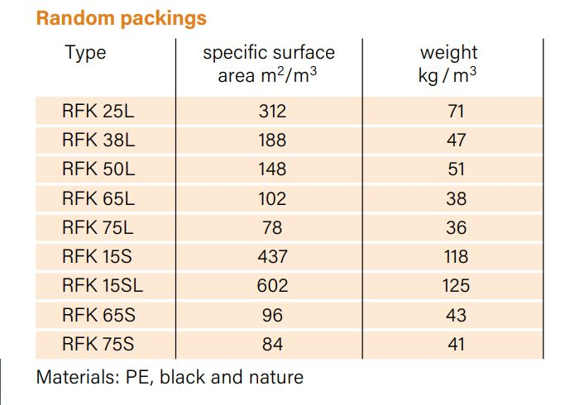

In total

1.635 kg of biocarriers = 1 m3 / 72 kg = 0.02302 m3 = 23 Liter

**HF25-7-PP (WHITE)**

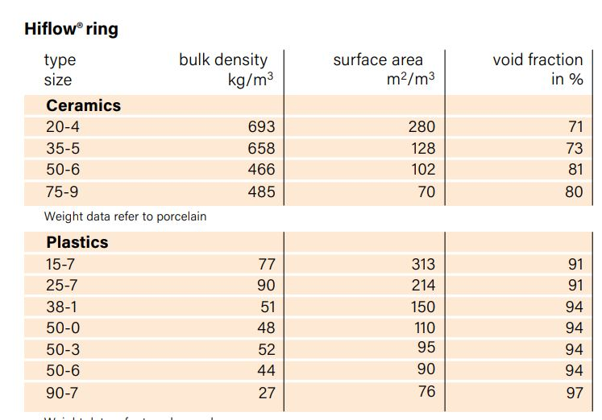

Total weight for 3zone = 0.02302 m3 * 91kg /1 m3 = 2.094 kg

each zone = 690 g

each HF25-7-PP is 1.96g

number of packings in each zone = 250